Supplementary Materials
Table S1. Proteins and their positive and negative regulators in the core control systems of mammalian cell cycle shown in Figure 1

Proteins | Regulators of proteins and their influence ( positive or negative
MYC | MYC
CDH1 | CYCE(-), CYCA(-),CYCB(-)
P27 | CYCD(-), CYCE(-), CYCA(-)
RB | CYCD(-), CYCE(-),CYCA(-)
CYCD | MYC(+), P27(-), SCF(-), CDC20(-)
E2F | RB(-), CYCD(+),CYCE(+),CYCA(-)
SCF | CYCE(+), CDH1(-)
CYCE | E2F(+), P27(-), SCF(-)
CYCA | E2F (+), CDH1(-), P27(-), CDC20(-), NFY(+)
NFY | CYCA (+)
CYCB | NFY (+), CDH1(-), CDC20(-)
CDC20 | CYCB (+), CDH(-)

Table S2. Weights from the trained whole system AANN with sigmoid functions and a priori unspecified protein interactions

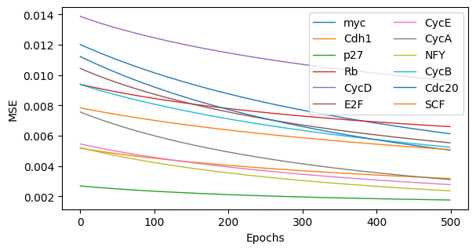
Figure S1: Training MSE plots for whole system AANN with all sigmoid neurons for the a priori specified connections in the protein network.

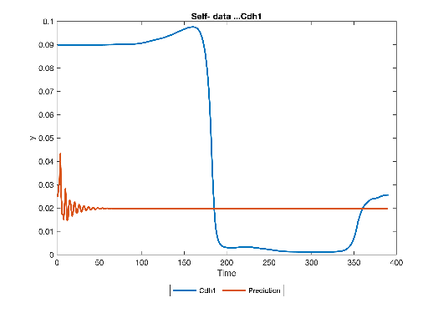
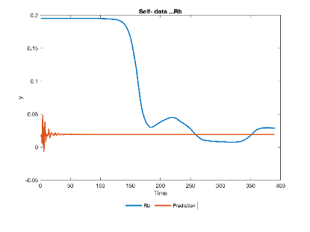
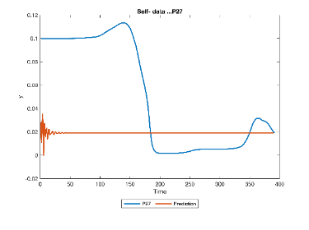
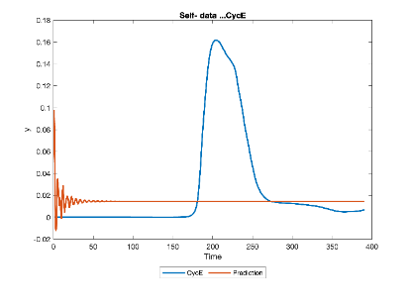
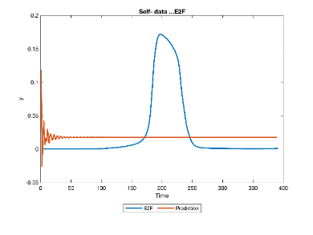
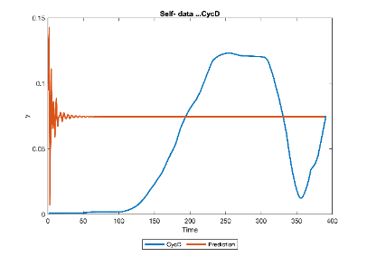

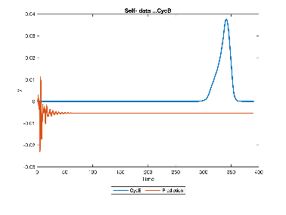
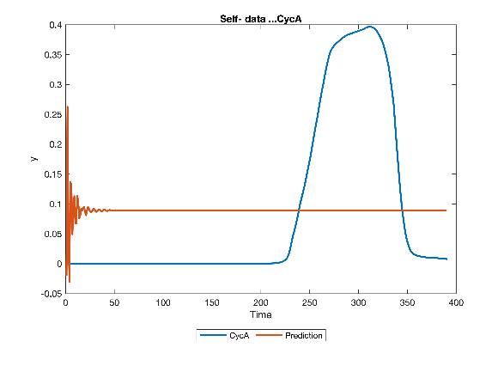
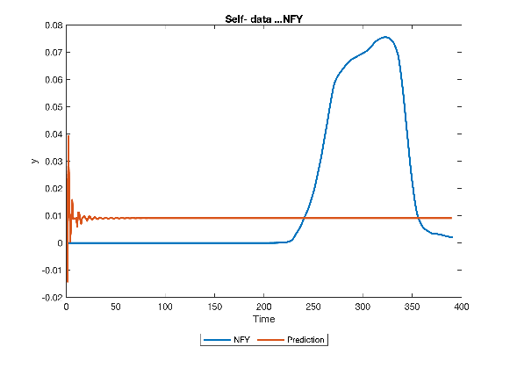
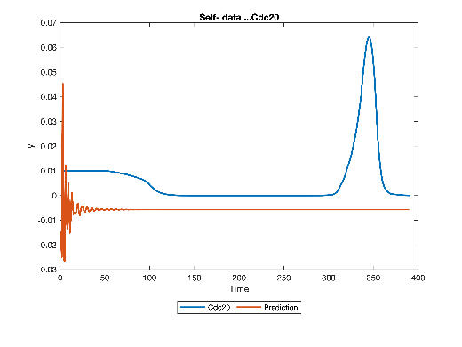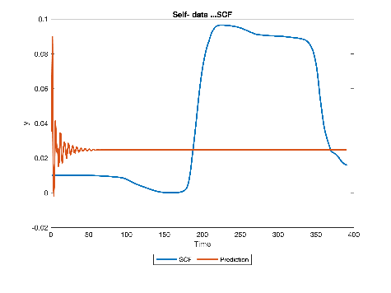
Figure S2. AANN whole system model prediction from its own system generated data (predicted (brown) and target (blue))

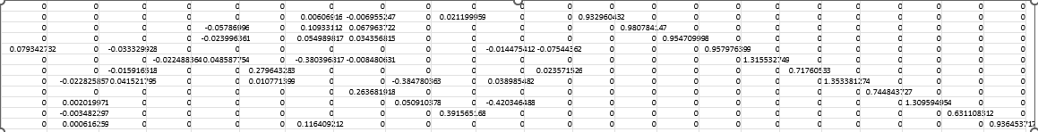
Table S3. Recurrent AANN weight matrix for recurrent inputs and standard inputs (all linear activation functions). Weights along the diagonal in the second half the matrix represent recurrent weights indicative of the strength of influence of past output.

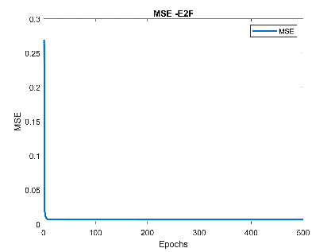
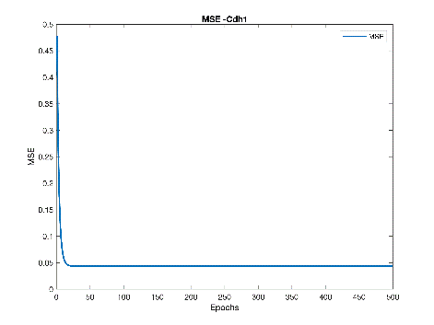
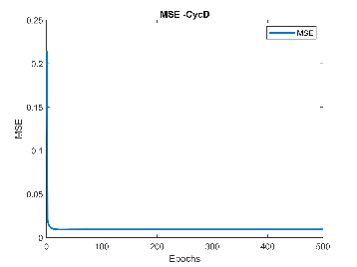
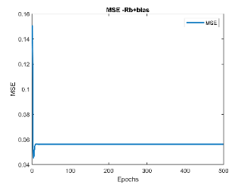
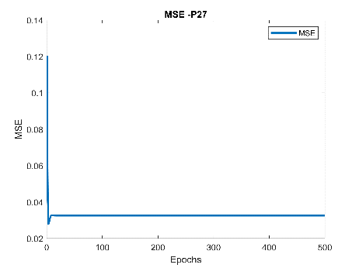
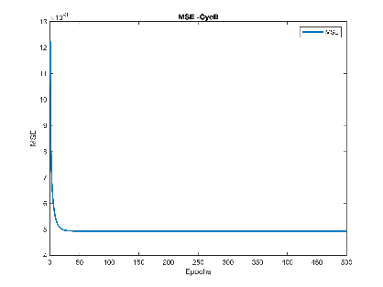
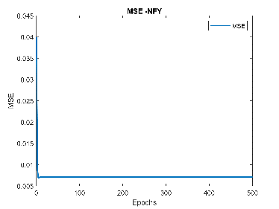
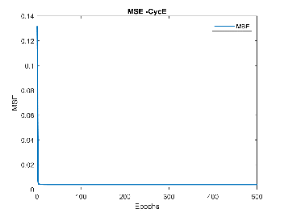

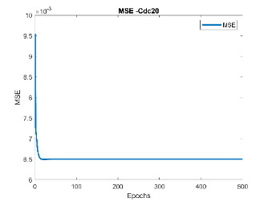

Figure S3. MSE graphs of training individual linear neurons for individual proteins

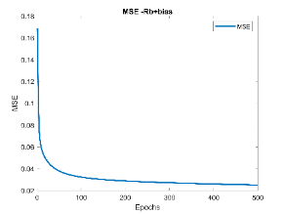
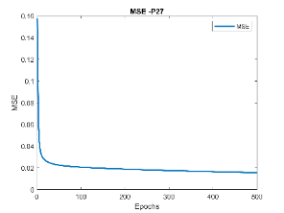
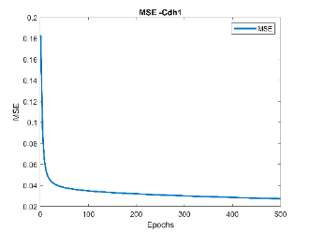

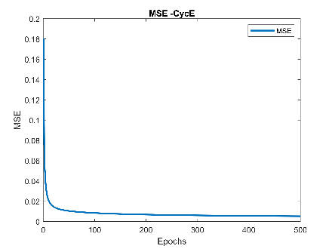
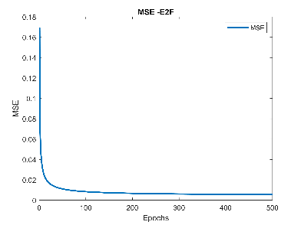
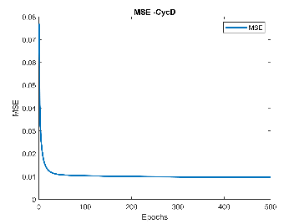
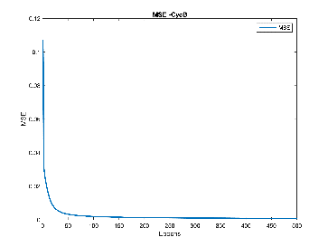
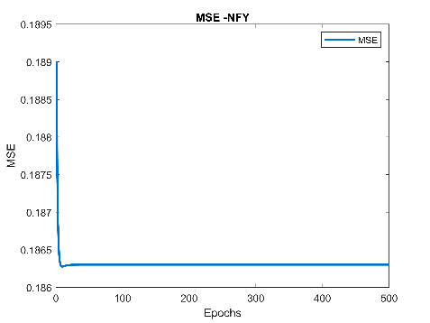
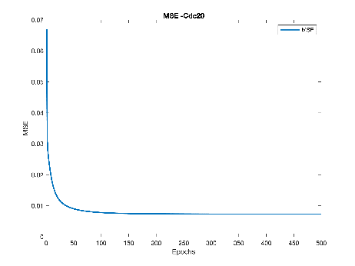

Figure S4. MSE graphs for training individual sigmoid neuron models for individual proteins

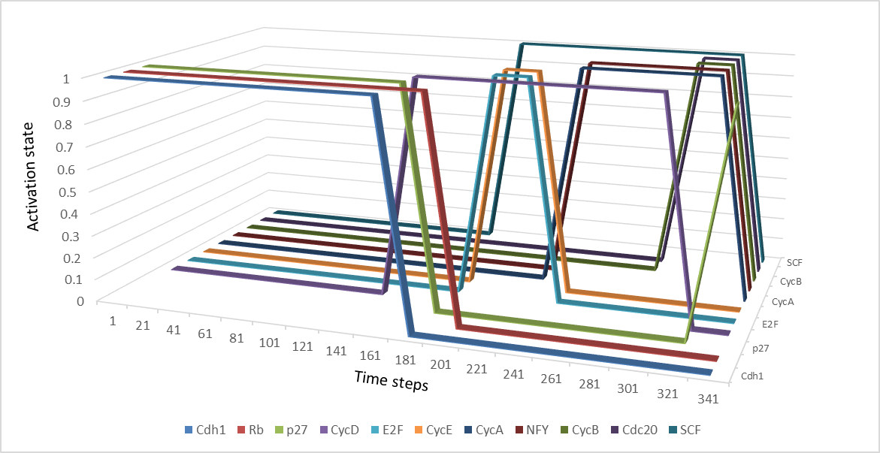

Figure S5. Performance of the Binary AANN model assembled from the individual binary neuron models trained from binary data generated from the ODE model data.

